Chris Badalucco

Two Things LLC. | 2 first street, Albany ny 12203

Project Advisor: Professor John Avitabile degree advisor: dr. ian macdonald

Requirements Specification

Jalopy Exchange Project

Table of Contents

1 The Purpose of the Project 1

1.1 The User Business or Background of the Project Effort 1

1.2 Goals of the Project 1

2 The Client 1

3 Users of the Product 1

4 Mandated Constraints 1

4.1 Solution Constraints 1

4.2 Schedule Constraints 1

5 Definitions 2

6 Assumptions 2

7 Functional Requirements / Scope of Work 2

7.1 The Current Situation 2

7.2 Users 2

7.3 Administrators 3

8 Data Requirements 3

8.1 Entity-Relationship Diagram 3

8.2 Database Tables 4

9 Look and Feel Requirements 8

9.1 Appearance Requirements 8

9.2 Style Requirements 8

10 Usability and Humanity Requirements 8

10.1 Ease of Use Requirements 8

10.2 Learning Requirements 8

10.3 Understandability and Politeness Requirements 8

10.4 Accessibility Requirements 9

11 Performance Requirements 9

11.1 Speed and Latency Requirements 9

11.2 Reliability and Availability Requirements 9

12 Maintainability Requirements 9

13 Security Requirements 9

13.1 Access Requirements 9

14 Open Issues 9

15 Risks 10

16 User Documentation 10

17 Waiting Room 10

# The Purpose of the Project

## The User Business or Background of the Project Effort

Two Things LLC. is looking to simplify the process of buying and selling cars by creating a hub for users where they can go and do business. Currently people in the market are limited to word of mouth, newspaper classifieds and for sale signs in car windows but these options are not ideal because it greatly limits the exposure of listings to consumers and vice versa.

## Goals of the Project

The goal of this project is to create a web application where car sellers can create listings and car buyers can come to search for existing listings. Having a web based solution expands seller exposure and allows buyers to easily search a broader region for listings.

# The Client

The client for this project is Two Things LLC.

# Users of the Product

* Administrators – full read/write access to the system.
* Registered Users - read access to system. Write access to specific content

# Mandated Constraints

## Solution Constraints

The product must be a web based solution. This allows the product to reach the largest potential customer base. The product shall be tested on the latest versions of Internet Explorer, Firefox and Google Chrome.

## Schedule Constraints

Initial Presentation: December 3, 2014

Final Presentation: December 10, 2014

# Definitions

* Listing: an entry that describes a given automobile that is on sale. A listing holds information such as the asking price, seller, automobile on sale, and eventually the buyer.
* Seller: a user who has one or more listings.
* Buyer: a user who is purchasing an automobile from the current listings.
* Administrator: a user with privileges superior to a standard user (described in further detail below)

# Assumptions

There is no dedicated/production environment expected for this project. Developers will run the application on local/development server(s).

# Functional Requirements

## The Current Situation

This is a new process with no ties to any legacy manual/automated processes. The goal is to have users migrate from other “offline” processes (e.g. newspaper ads and word of mouth) to our online application.

The system shall comprise of Users and Administrators:

## Users

* View all listings (active and closed)
* Purchase an automobile through an active listing
* Add/Delete automobiles to their account
* Create one listing per automobile they have in the system
* Close their listings prior to a purchase being made
* Edit their own user details

## Administrators

* View all listings (active and closed)
* Toggle all listings between active and closed status
* Edit all users details
* Lock/unlock user accounts from accessing the system

# Scope of Work

## UML Use Case Diagram

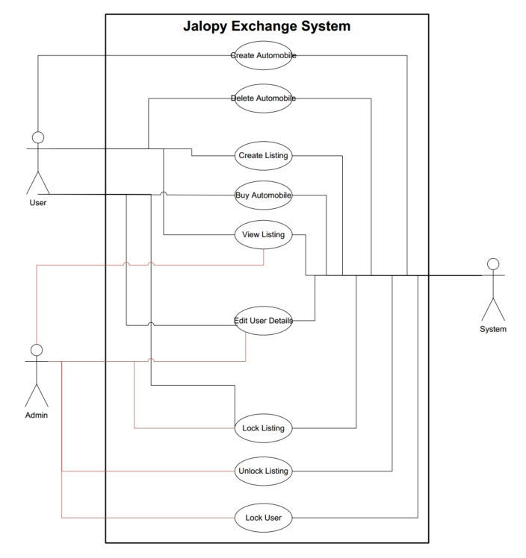

## Class Diagram

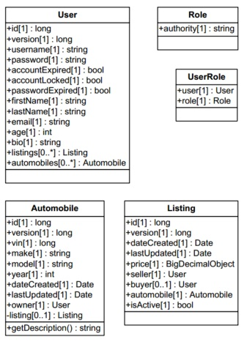

# Data Requirements

## Entity-Relationship Diagram

NOTE: An interactive HTML version of the ERD is available in the “docs” folder of the system source code

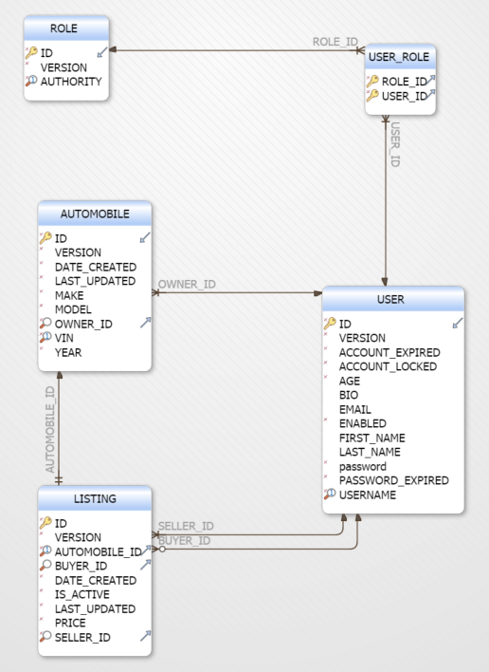

## Database Tables

| **Table ROLE** | | | | | |
| --- | --- | --- | --- | --- | --- |
| * | ID | | bigint DEFO (NEXT VALUE FOR PUBLIC.SYSTEM_SEQUENCE_11CDFA44_4778_422D_B68E_B82491E2AA59) | |  | |
| * | VERSION | bigint | |  | |
| * | AUTHORITY | varchar( 255 ) | |  | |
| **Indexes** | | | | | |
| Pk | CONSTRAINT_2 | ON ID | |  | |
| U | UK_IRSAMGNERA6ANGM0PRQ1KEMT2_INDEX_2 | ON AUTHORITY | |  | |

| **Table USER_ROLE** | | | |
| --- | --- | --- | --- |
| * | ROLE_ID | bigint |  |
| * | USER_ID | bigint |  |
| **Indexes** | | | |
| Pk | CONSTRAINT_B | ON ROLE_ID, USER_ID |  |
|  | FK_APCC8LXK2XNUG8377FATVBN04_INDEX_B | ON USER_ID |  |
| **Foreign Keys** | | | |
|  | FK_IT77EQ964JHFQTU54081EBTIO | ( ROLE_ID ) ref ROLE (ID) |  |
|  | FK_APCC8LXK2XNUG8377FATVBN04 | ( USER_ID ) ref USER (ID) |  |

| **Table AUTOMOBILE** | | | | | |
| --- | --- | --- | --- | --- | --- |
| * | ID | bigint DEFO (NEXT VALUE FOR PUBLIC.SYSTEM_SEQUENCE_D6A71DE3_F6C6_4396_BE30_CD4F7A732B2A) | | |  | |
| * | VERSION | | bigint |  | |
| * | DATE_CREATED | | timestamp |  | |
| * | LAST_UPDATED | | timestamp |  | |
| * | MAKE | | varchar( 255 ) |  | |
| * | MODEL | | varchar( 255 ) |  | |
| * | OWNER_ID | | bigint |  | |
| * | VIN | | bigint |  | |
| * | YEAR | | integer |  | |
| **Indexes** | | | | | |
| Pk | CONSTRAINT_3 | | ON ID |  | |
| U | UK_9DS6FW9JCXA2D86PC6QFSLDAB_INDEX_3 | | ON VIN |  | |
|  | FK_YAIXHDOFC2AHBVO87F4KXNFD_INDEX_3 | | ON OWNER_ID |  | |
| **Foreign Keys** | | | | | |
|  | FK_YAIXHDOFC2AHBVO87F4KXNFD | | ( OWNER_ID ) ref USER (ID) |  | |

| **Table LISTING** | | | |
| --- | --- | --- | --- |
| * | ID | bigint DEFO (NEXT VALUE FOR PUBLIC.SYSTEM_SEQUENCE_DD690853_1C9C_4D86_A829_71FD3A86D035) |  |
| * | VERSION | bigint |  |
| * | AUTOMOBILE_ID | bigint |  |
|  | BUYER_ID | bigint |  |
| * | DATE_CREATED | timestamp |  |
| * | IS_ACTIVE | boolean |  |
| * | LAST_UPDATED | timestamp |  |
| * | PRICE | decimal( 19 ) |  |
| * | SELLER_ID | bigint |  |
| **Indexes** | | | |
| Pk | CONSTRAINT_35 | ON ID |  |
| U | UK_BLQC2QNSV34VDIJ2WDCJA6HP1_INDEX_3 | ON AUTOMOBILE_ID |  |
|  | FK_3FD1L12TYDNGSG3JK09360EXU_INDEX_3 | ON SELLER_ID |  |
|  | FK_MR2WLVMJAO25KOSDRJ07SX6X5_INDEX_3 | ON BUYER_ID |  |
| **Foreign Keys** | | | |
|  | FK_BLQC2QNSV34VDIJ2WDCJA6HP1 | ( AUTOMOBILE_ID ) ref AUTOMOBILE (ID) |  |
|  | FK_3FD1L12TYDNGSG3JK09360EXU | ( SELLER_ID ) ref USER (ID) |  |
|  | FK_MR2WLVMJAO25KOSDRJ07SX6X5 | ( BUYER_ID ) ref USER (ID) |  |

| **Table USER** | | | |
| --- | --- | --- | --- |
| * | ID | bigint DEFO (NEXT VALUE FOR PUBLIC.SYSTEM_SEQUENCE_8FF9F30E_E968_4978_8208_BA490A969147) |  |
| * | VERSION | bigint |  |
| * | ACCOUNT_EXPIRED | boolean |  |
| * | ACCOUNT_LOCKED | boolean |  |
| * | AGE | integer |  |
|  | BIO | varchar( 255 ) |  |
|  | EMAIL | varchar( 255 ) |  |
| * | ENABLED | boolean |  |
|  | FIRST_NAME | varchar( 255 ) |  |
|  | LAST_NAME | varchar( 255 ) |  |
| * | password | varchar( 255 ) |  |
| * | PASSWORD_EXPIRED | boolean |  |
| * | USERNAME | varchar( 255 ) |  |
| **Indexes** | | | |
| Pk | CONSTRAINT_27 | ON ID |  |
| U | UK_SB8BBOUER5WAK8VYIIY4PF2BX_INDEX_2 | ON USERNAME |  |

# Look and Feel Requirements

## Appearance Requirements

The system shall have a modern feel. The system shall have a functional and an appealing appearance at a resolution of 1024x768 and higher. The system does not have a requirement to be mobile friendly at this time.

## Style Requirements

The system must have a modern feel that mimics the “flat” design found on modern sites and mobile ecosystems. There are no specific color choices that are required.

# Usability and Humanity Requirements

## Ease of Use Requirements

The system shall be easy for adults to use. The system will help prevent users from making mistakes by limiting their options as much as possible to acceptable input. The system will provide feedback through tooltips and alert messages to help guide the user.

## Learning Requirements

The system shall be able to be used by users who receive little to no formal training before using it.

## Understandability and Politeness Requirements

The system shall use language and symbols (icons) familiar with the general user base. The details of the system shall be hidden for users.

## Accessibility Requirements

The system shall be accessible at resolutions as low as 1024x768. There is no requirement regarding mobile accessibility.

# Performance Requirements

* This section is for reference only. Strict requirements cannot be accurately defined without knowing the final production environment specifications.

## Speed and Latency Requirements

The system shall be fast enough to avoid interrupting the user’s flow of thought. Asynchronous requests must complete in the standard timeframe of thirty seconds or less.

## Reliability and Availability Requirements

The system shall achieve a 95 percent uptime.

# Maintainability Requirements

The system must be able to be updated with an hour or less of downtime.

# Security Requirements

## Access Requirements

* Administrators can lock user accounts
* Only Administrators can see all the users account information (excluding password)
* Users with an active account can access the system

# Open Issues

It are still unknowns surrounding the production environment:

* Where will it be hosted?
* What hardware resources will be available / how much bandwidth is available?

# Risks

* Single resource for the entire project process
  + Resource has a prior commitment which allocates 40 hours per week
  + Resource is moving in the middle of November
* Scope Creep

# User Documentation

* Requirements Specification (this document)
* Software Design
* User’s Guide
* Developers’ Guide (README)

# Waiting Room

* Uploading images for automobiles
* Public accessible create user process
* Observer (read only) access to the system for all non-registered users
* Provide a bidding service where potential buyers can make offers for automobiles (in addition to the static “buy it now” option)
* Convert the system to a persisted data source. Either server hosted version of H2, or any other common database technologies e.g. MySQL, Oracle, PostgreSQL.